JavaScript DOM Manipulation Examples
- Change text of an element using getElementById.

Code:
<!DOCTYPE html>
<html lang="en">
<head>
<meta charset="UTF-8">
<meta name="viewport" content="width=device-width, initial-scale=1.0">
<title>Text Change</title>
<style>
body {
font-family: Arial, sans-serif;
background: linear-gradient(to right, #74ebd5, #9face6);
text-align: center;
padding-top: 100px;
}
#p1 {
font-size: 28px;
color: #333;
background-color: white;
display: inline-block;
padding: 15px 25px;
border-radius: 10px;
box-shadow: 0px 4px 10px rgba(0,0,0,0.2);
transition: 0.3s;
}
button {
margin-top: 20px;
padding: 12px 25px;
font-size: 18px;
border: none;
border-radius: 8px;
background-color: #4CAF50;
color: white;
cursor: pointer;
transition: 0.3s;
}
button:hover {
background-color: #7a8baa;
transform: scale(1.05);
}
</style>
</head>
<body>
<p id="p1">Hello I'm Sadham</p>
<br>
<button onclick="changetext()">Click Here</button>

<script>
function changetext(){
document.getElementById("p1").textContent = 'Hi I\'m SOFTWARE DEVELOPER';
}
</script>
</body>
</html>
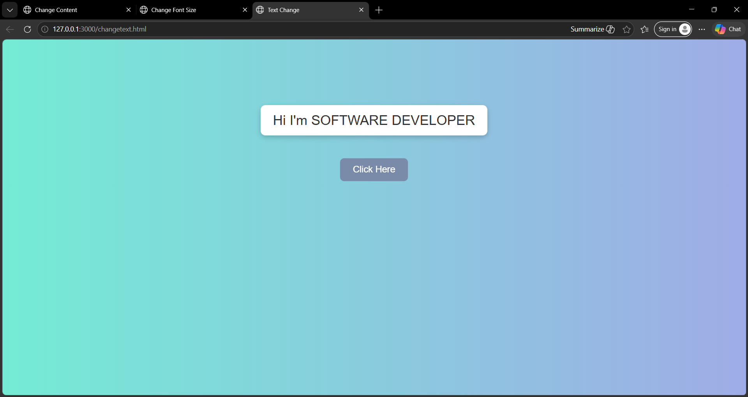
OUTPUT:
- Select an element and change its style.

Code:
<!DOCTYPE html>
<html lang="en">
<head>
<meta charset="UTF-8">
<meta name="viewport" content="width=device-width, initial-scale=1.0">
<title>Style Change</title>
<style>
body {
font-family: Arial, sans-serif;
text-align: center;
background: linear-gradient(to right, #ffecd2, #fcb69f);
padding-top: 100px;
}

#p1 {
font-size: 24px;
background-color: white;
padding: 20px;
border-radius: 10px;
display: inline-block;
box-shadow: 0px 4px 8px rgba(0,0,0,0.2);
transition: 0.4s;
}
button {
margin-top: 20px;
padding: 12px 20px;
font-size: 18px;
border: none;
border-radius: 8px;
background-color: #ff5722;
color: white;
cursor: pointer;
transition: 0.3s;
}

button:hover {
background-color: #e64a19;
transform: scale(1.05);
}
</style>
</head>
<body>
<p id="p1">IF YOU CLICK ME I WILL CHANGE MY ORIGINAL FORM</p>
<br>
<button onclick="changestyle()">Click Me</button>
<script>
function changestyle(){
let element = document.getElementById("p1");
element.style.color = "red";
element.style.backgroundColor = "yellow";
element.style.fontFamily = "Times New Roman";
element.style.fontSize = "28px";
document.getElementById("p1").textContent="IM FRONT END DEVELOPER ";
}
</script>
</body>
</html>
OUTPUT:
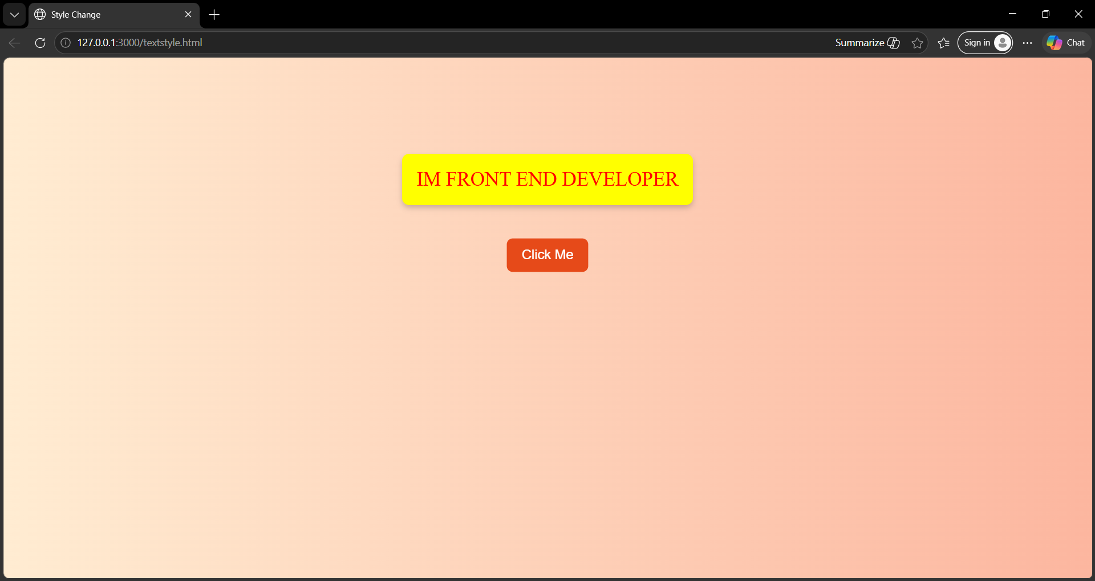

- Change content of a paragraph.

Code:
<!doctype html>
<html lang="en">
<head>
<meta charset="UTF-8" />
<meta name="viewport" content="width=device-width, initial-scale=1.0" />
<title>Change Content</title>
<style>
body {
font-family: Arial, sans-serif;
background: linear-gradient(to right, #a1c4fd, #c2e9fb);
text-align: center;
padding: 60px;
}
#p1 {
background-color: white;
padding: 20px;
border-radius: 10px;
font-size: 18px;
line-height: 1.6;
box-shadow: 0px 4px 10px rgba(0,0,0,0.2);
transition: 0.5s;
max-width: 600px;
margin: auto;
}
button {
margin-top: 20px;
padding: 12px 25px;
font-size: 18px;
border: none;
border-radius: 8px;
background-color: #2196f3;
color: white;
cursor: pointer;
transition: 0.3s;
}
button:hover {
background-color: #67821f;
transform: scale(1.05);
}
.highlight {
background-color: yellow;
color: red;
transform: scale(1.03);
}
</style>

</head>
<body>

<p id="p1">
OLD CONTENT PARAGRAPH Lorem ipsum dolor sit, amet consectetur adipisicing
elit. Optio, placeat quae...
</p>
<button onclick="changepara()">Click Here</button>
<script>
function changepara() {
let para = document.getElementById("p1");

para.textContent = "NEW CONTENT PARAGRAPH Welcome to JavaScript DOM!";
}
</script>
</body>
</html>
Output: 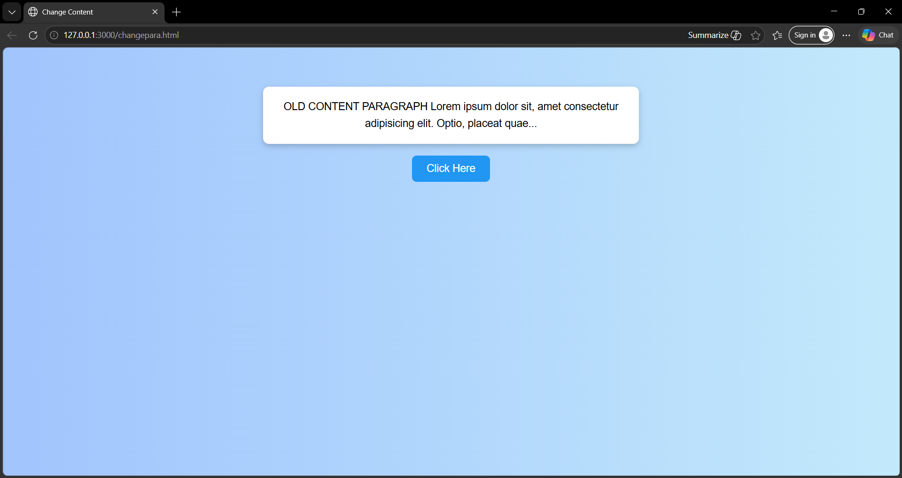

- Change color and font size of text.

Code:
<!DOCTYPE html>
<html lang="en">
<head>
<meta charset="UTF-8">
<meta name="viewport" content="width=device-width, initial-scale=1.0">
<title>Change Font Size</title>
<style>
body {
font-family: Arial, sans-serif;
text-align: center;
background: linear-gradient(to right, #84fab0, #8fd3f4);
padding-top: 100px;
}

#p1 {
font-size: 22px;
background-color: white;
padding: 20px;
border-radius: 10px;
display: inline-block;
box-shadow: 0px 4px 10px rgba(0,0,0,0.2);
transition: 0.4s;
}
button {
margin-top: 20px;
padding: 12px 25px;
font-size: 18px;
border: none;
border-radius: 8px;
background-color: #673ab7;
color: white;
cursor: pointer;
transition: 0.3s;
}
button:hover {
background-color: #5e35b1;
transform: scale(1.05);
}
</style>
</head>
<body>
<p id="p1">Python Full Stack Developer</p>
<br>
<button onclick="changefontsize()">Click Me</button>
<script>
let isChanged = false;

function changefontsize(){
let element = document.getElementById("p1");

if(!isChanged){
element.style.color = "blue";
element.style.fontSize = "30px";
element.style.fontWeight = "bold";
isChanged = true;
} else {
element.style.color = "black";
element.style.fontSize = "22px";
element.style.fontWeight = "normal";
isChanged = false;
}
}
</script>
</body>
</html>
Output:
